**Lesson08 Using GitHub to publish asp.net project to Azure App Service**

**Notes:-**

**1-create new MVC app**

**2-install the MVC Github extension as below** <https://marketplace.visualstudio.com/items?itemName=GitHub.GitHubExtensionforVisualStudio>

**3-on VS 2019 we connect to github account**

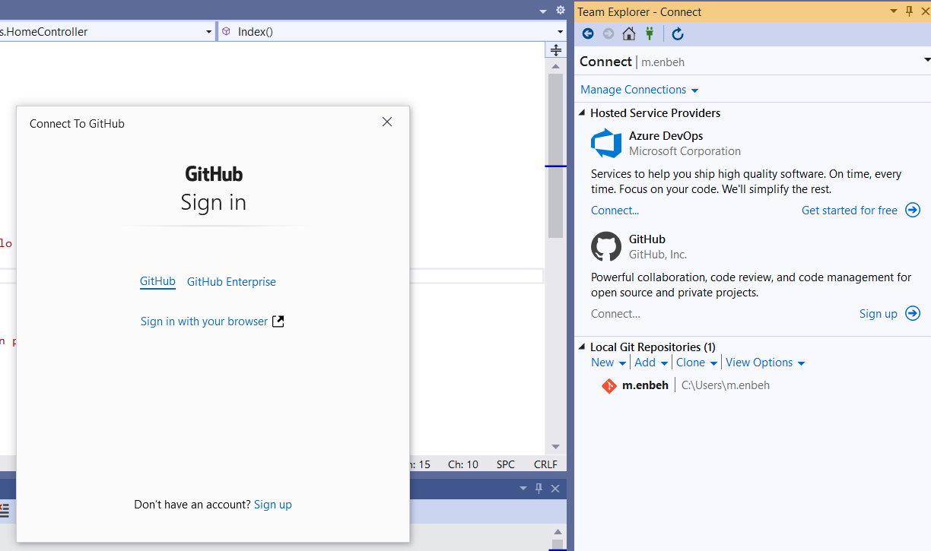

**4-We click on the Sign in With your browser > Authorize Github**

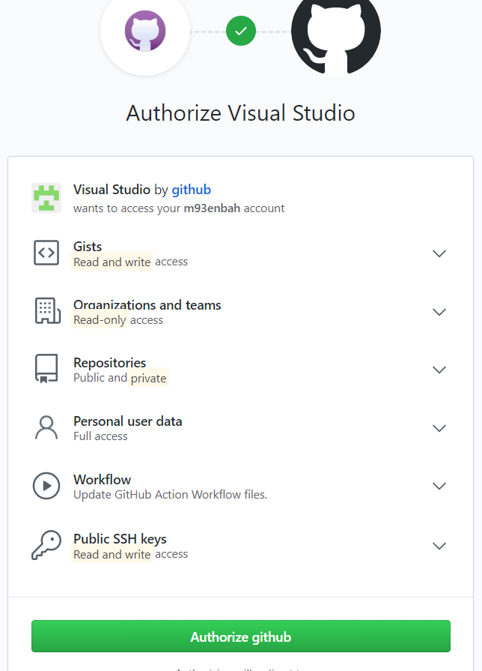

**5-on Github repository > create new Github repository as below**

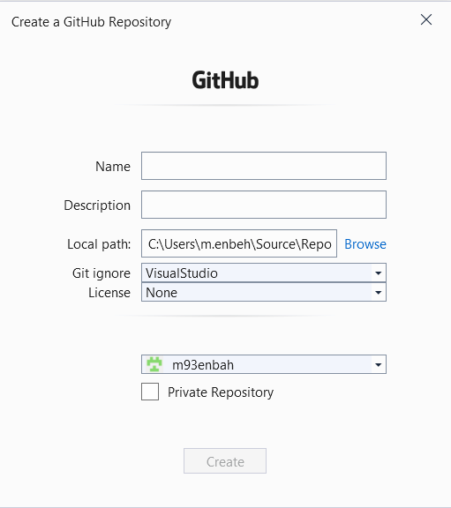

**(you will see that new github repository is created)**

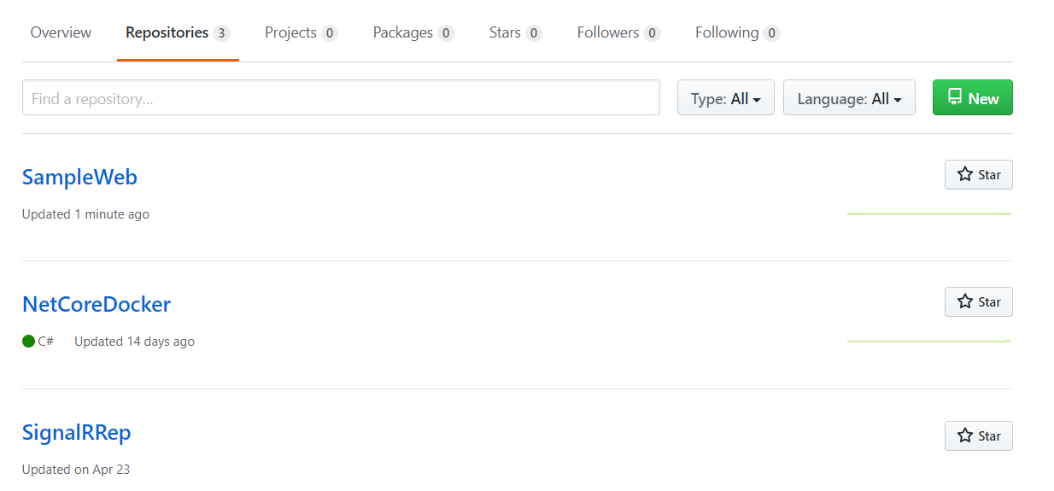

**7-we team explorer > connect tool > create new local repository path (SYNC OP)**

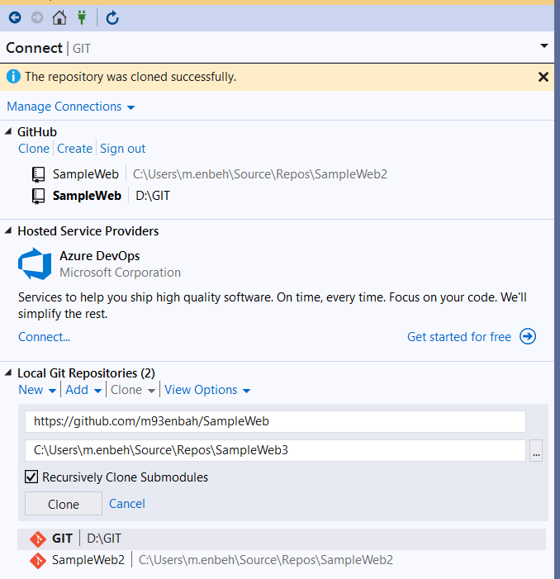

(we also make sure that is sync between server and local)

8-we view the changes > team explorer > changes > we see the change happens

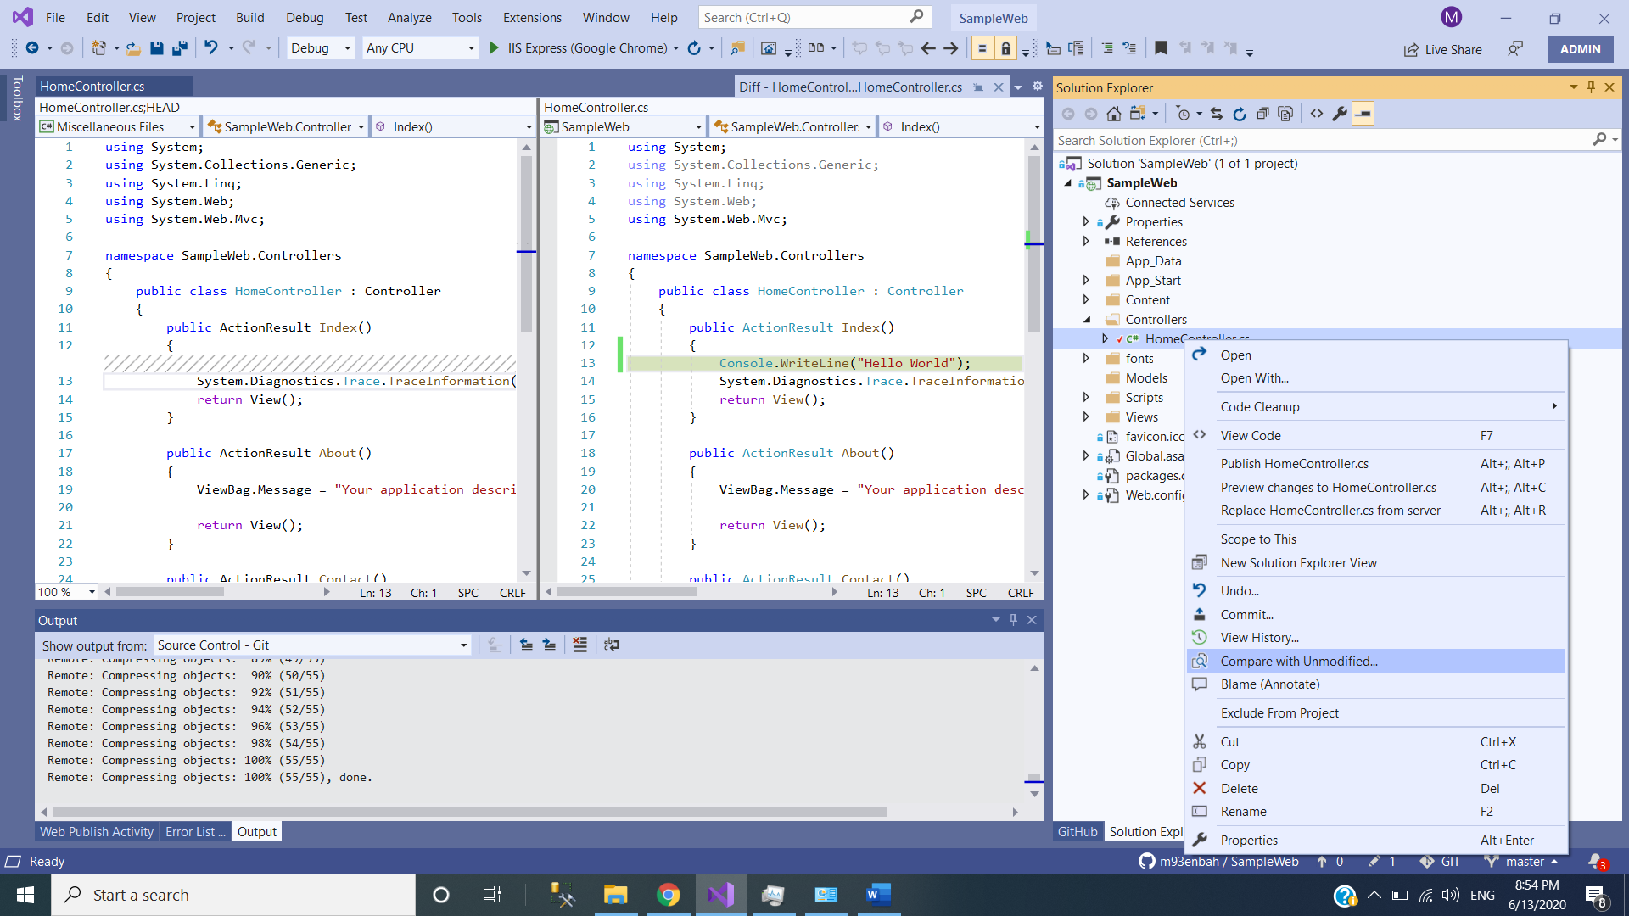

9-on Azure portal > Deployment center > Github > Click Authorize on this part too , to make sure to apply SYNC operation between Github and the app service

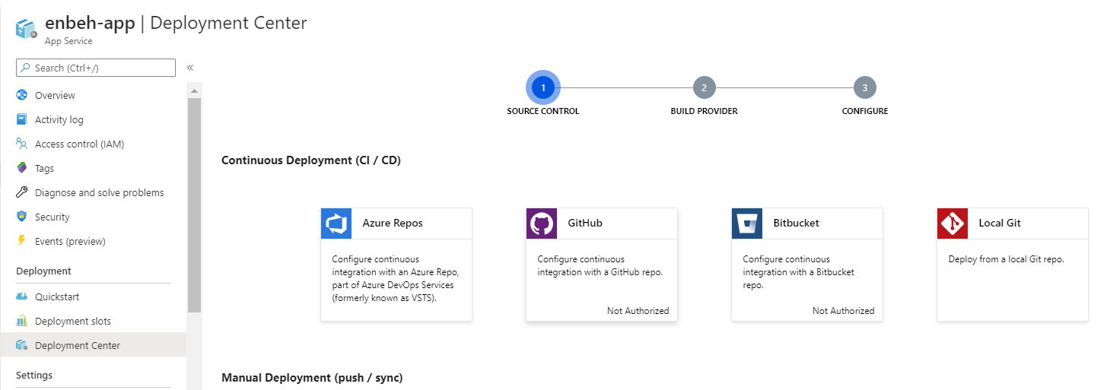

10-we select App service build to make sure that it will automatically build your solution

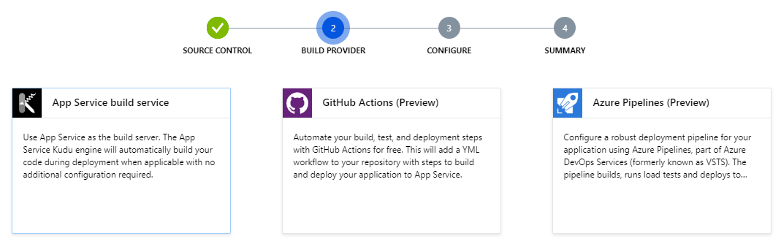

11-we select the repository and branch as below

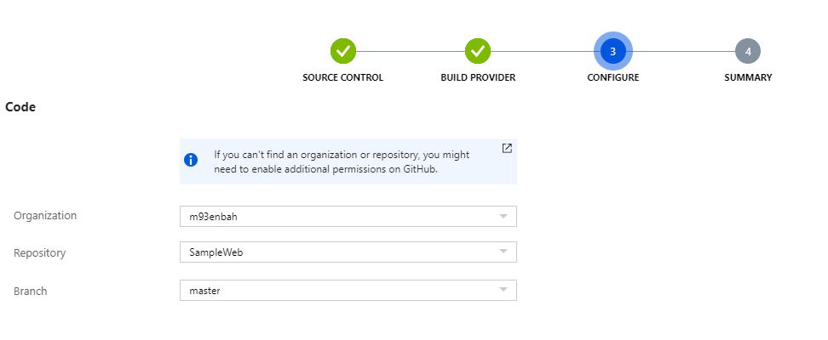

12-we see that app service is now deploy the github repository automatically

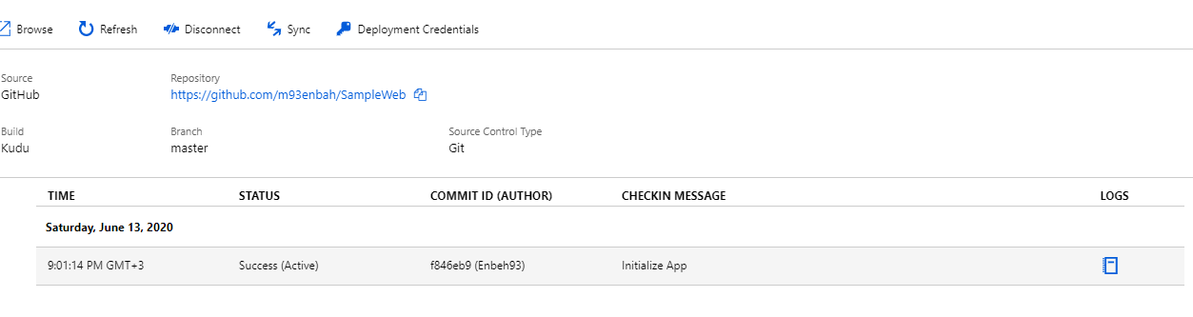

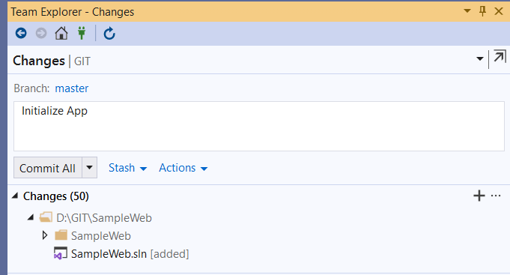

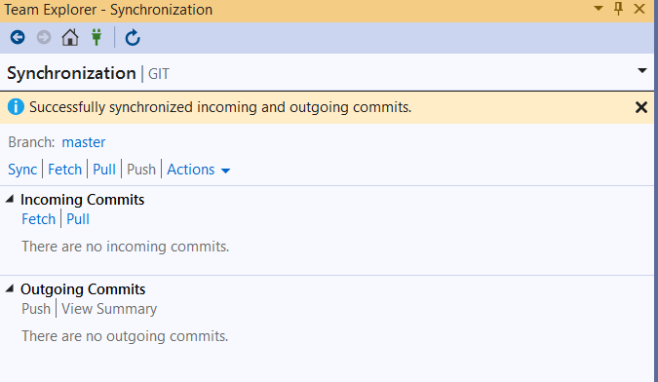

**It will create Github Repository as show in Github page**